Problem 1
/**
* CT255 - Assignment 4
* Skeleton code for Steganography assignment.
*
* @author Michael Schukat
* @version 1.0
*/
import java.io.BufferedReader;
import java.io.BufferedWriter;
import java.io.FileReader;
import java.io.FileWriter;
import java.io.IOException;
// binary for ciaran: 011000110110100101100001011100100110000101101110
//binary for gray: 01100111 01110010 01100001 01111001
public class Stegano1 {
/**
* Constructor for objects of class Stegano1
*/
public Stegano1() {
}
public static void main(String[] args) {
String arg1, arg2, arg3, arg4;
boolean err = false;
if (args != null && args.length > 1) { // Check for minimum number of arguments
arg1 = args[0];
arg2 = args[1];
if (arg2.isEmpty()) {
err = true;
} else if ((arg1.equals("A")) && (args.length > 3)) {
// Get other arguments
arg3 = args[2];
arg4 = args[3];
if ((arg3.isEmpty()) || (arg4.isEmpty())) {
err = true;
} else {
// Hide bitstring
hide(arg2, arg3, arg4);
}
} else if (arg1.equals("E")) {
// Extract bitstring from text
retrieve(arg2);
} else {
err = true;
}
} else {
err = true;
}
if (err) {
System.out.println();
System.out.println("Use: Stegano1 <A:E><Input File><OutputFile><Bitstring>");
System.out.println("Example: Stegano1 A inp.txt out.txt 0010101");
System.out.println("Example: Stegano1 E inp.txt");
}
}
static void hide(String inpFile, String outFile, String binString) {
BufferedReader reader;
BufferedWriter writer;
try {
reader = new BufferedReader(new FileReader(inpFile));
writer = new BufferedWriter(new FileWriter(outFile));
String line = reader.readLine();
int bitIndex = 0;
while (line != null) {
// store amended line in output file
if (bitIndex < binString.length()) {
//problem 1
//save the current index of bit string as a character
char bit = binString.charAt(bitIndex);
if (bit == '0') {
line += " "; // add one space to the line for 0
} else if (bit == '1') {
line += " "; // add two spaces to the line for 1
}
bitIndex++; //increase the index of the bit string
}
writer.write(line);
writer.newLine();
// read next line
line = reader.readLine();
}
reader.close();
writer.close();
} catch (IOException e) {
e.printStackTrace();
}
}
static void retrieve(String inpFile) {
BufferedReader reader;
try {
reader = new BufferedReader(new FileReader(inpFile));
String line = reader.readLine();
String result = ""; // string to hold the binary result
while (line != null) {
// Your code starts here
System.out.println(line); //read the next line
// if the line ends with two spaces, add 1 to result
if (line.endsWith(" ")) {
result += "1";
}
// if the line ends with one space, add 0 to result
else if (line.endsWith(" ")) {
result += "0";
}
//if the line does not end with a space, add nothing to result
else {
result += " ";
}
line = reader.readLine();
}
System.out.println("Expected Output: \n011000110110100101100001011100100110000101101110\n");
System.out.println("Actual Output: \n" + result);
reader.close();
} catch (IOException e) {
e.printStackTrace();
}
}
}

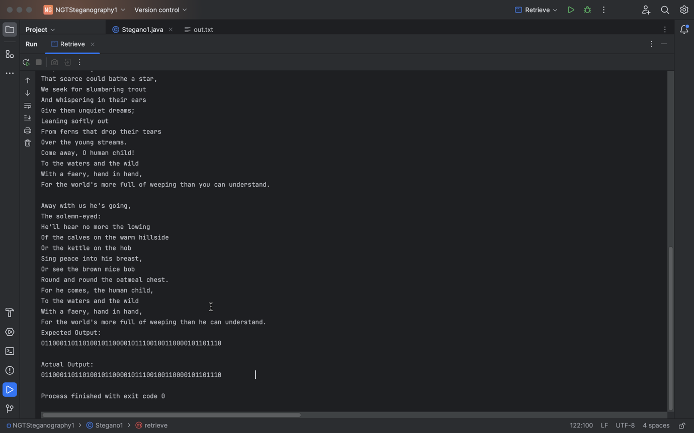

Problem 2

/**
* CT255 - Assignment 4
* Skeleton code for Steganography assignment.
*
* @author Michael Schukat
* @version 1.0
*/
import java.io.BufferedReader;
import java.io.BufferedWriter;
import java.io.FileReader;
import java.io.FileWriter;
import java.io.IOException;
// binary for ciaran: 011000110110100101100001011100100110000101101110
//binary for gray: 01100111011100100110000101111001
public class Stegano1 {
/**
* Constructor for objects of class Stegano1
*/
public Stegano1() {
}
public static void main(String[] args) {
String arg1, arg2, arg3, arg4;
boolean err = false;
if (args != null && args.length > 1) { // Check for minimum number of arguments
arg1 = args[0];
arg2 = args[1];
if (arg2.isEmpty()) {
err = true;
} else if ((arg1.equals("A")) && (args.length > 3)) {
// Get other arguments
arg3 = args[2];
arg4 = args[3];
if ((arg3.isEmpty()) || (arg4.isEmpty())) {
err = true;
} else {
// Hide bitstring
hide(arg2, arg3, arg4);
}
} else if (arg1.equals("E")) {
// Extract bitstring from text
retrieve(arg2);
} else {
err = true;
}
} else {
err = true;
}
if (err) {
System.out.println();
System.out.println("Use: Stegano1 <A:E><Input File><OutputFile><Bitstring>");
System.out.println("Example: Stegano1 A inp.txt out.txt 0010101");
System.out.println("Example: Stegano1 E inp.txt");
}
}
static void hide(String inpFile, String outFile, String binString) {
BufferedReader reader;
BufferedWriter writer;
try {
reader = new BufferedReader(new FileReader(inpFile));
writer = new BufferedWriter(new FileWriter(outFile));
String line = reader.readLine();
int bitIndex = 0;
//padding bit if the length is odd
if (binString.length() % 2 != 0) {
binString += "0";
}
while (line != null) {
if (bitIndex < binString.length()) {
//Problem 2
//divides the bitstring into a substring of 2 length, and checks that substring for bit values
int bitIndextwo = bitIndex + 2;
String twobits = binString.substring(bitIndex, bitIndextwo);//substring
//adds a certain ammount of spaces to the end of the lines depending on what digits are in the substring
if (twobits.equals("00")) {
line += " "; // 1 space for 00
}
else if (twobits.equals("01")) {
line += " "; // 2 for 01
}
else if (twobits.equals("10")) {
line += " "; // 3 for 10
}
else if (twobits.equals("11")) {
line += " "; // 4 for 11
}
}
writer.write(line);
writer.newLine();
// read next line
line = reader.readLine();
bitIndex += 2; //increase the index of the bitstring
}
reader.close();
writer.close();
} catch (IOException e) {
e.printStackTrace();
}
}
static void retrieve(String inpFile) {
BufferedReader reader;
try {
reader = new BufferedReader(new FileReader(inpFile));
String line = reader.readLine();
String result = ""; // string to hold the binary result
while (line != null) {
// Your code starts here
System.out.println(line); //read the next line
//Problem 2
//checks firstly for 4 spaces, then 3, then 2, then 1.
//adds back the corrosponding binary digits to the number of spaces
if (line.endsWith(" ")) {
result += "11";
} else if (line.endsWith(" ")) {
result += "10";
} else if (line.endsWith(" ")) {
result += "01";
} else if (line.endsWith(" ")) {
result += "00";
}
else {
result += " "; //if theres no spaces, it adds nothing
}
line = reader.readLine();
}
System.out.println("Expected Output: \n01100111011100100110000101111001\n");
System.out.println("Actual Output: \n" + result);
reader.close();
} catch (IOException e) {
e.printStackTrace();
}
}
}
